**Tableau Project on Amazon Pantry**

Q1) Create a dashboard for senior management for Chicago to view sales of personal care products for the last 6 months. Make assumptions as appropriate and create the dashboard using your own mock data. For any missing data make your assumptions to create mock data. Write down the assumptions as well.

Ans) The below mentioned are the screenshots of the dashboard of Personal Care Products

For senior Management of Chicago:

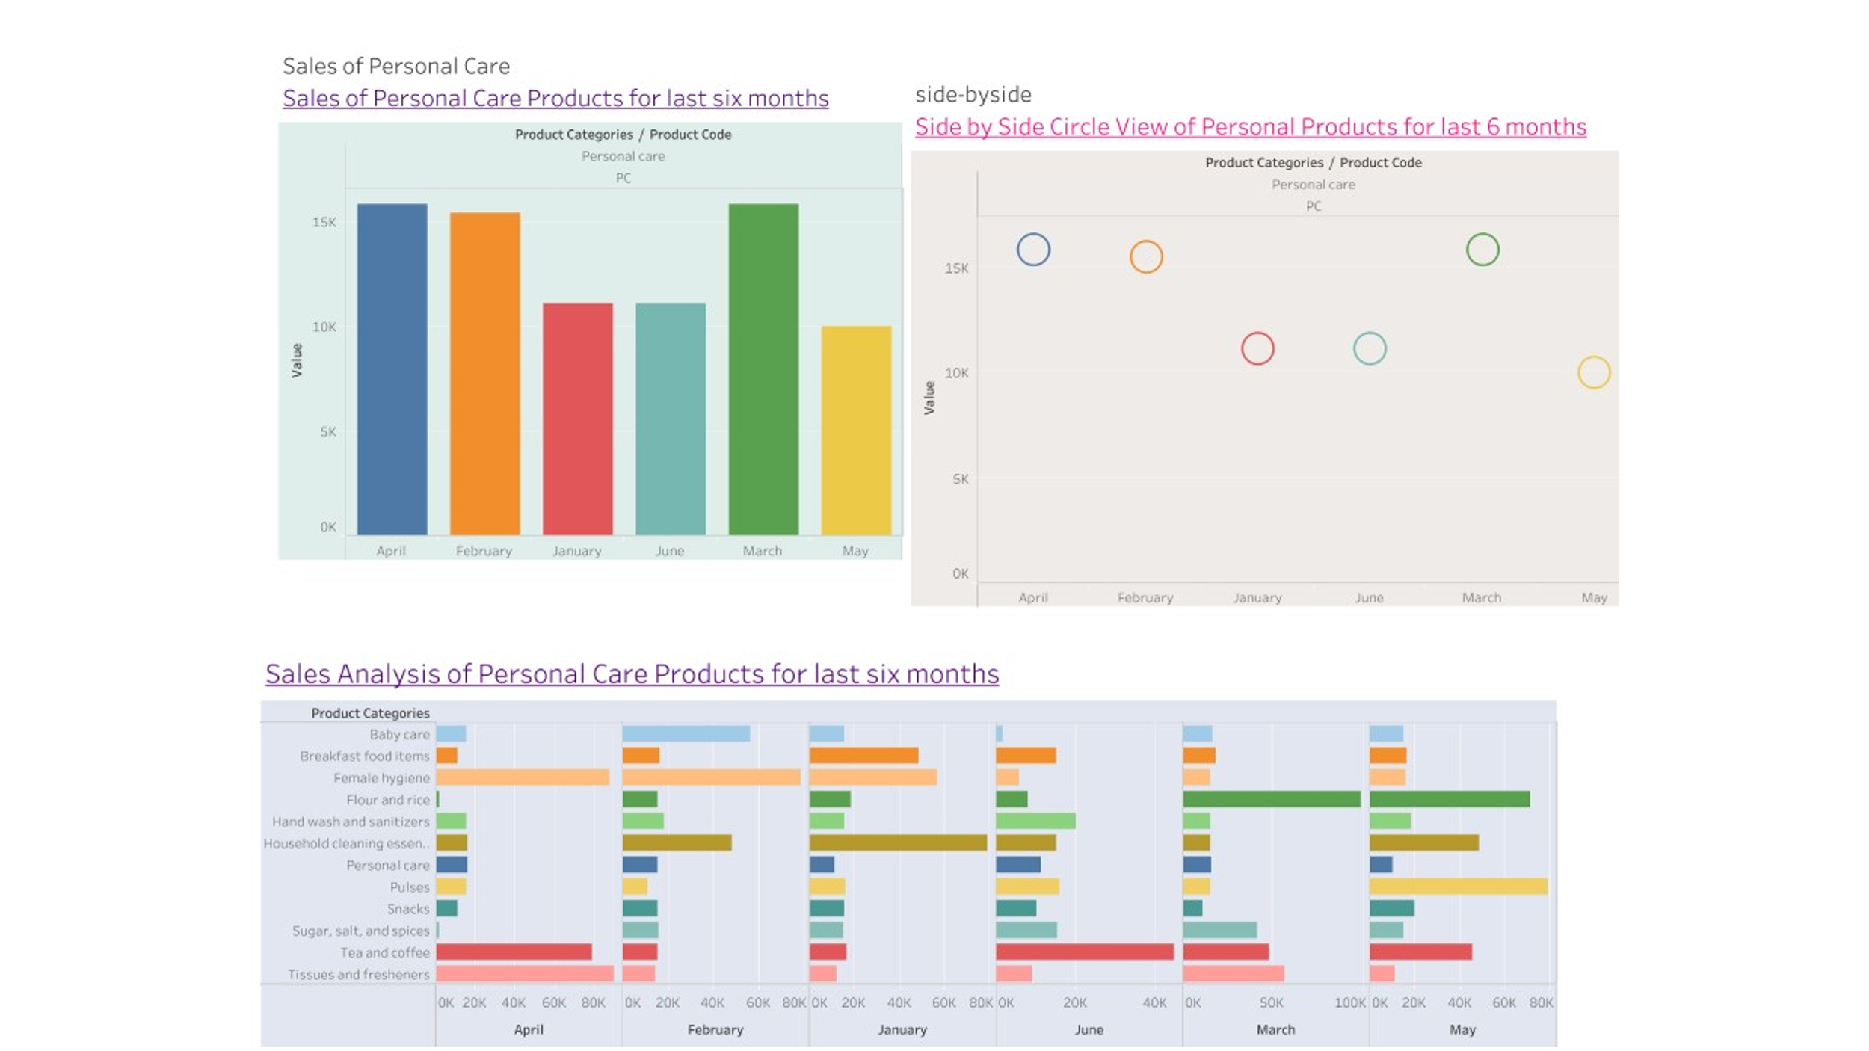

Q2) Create a dashboard to show Senior Management for Chicago to view sales of breakfast products for the last six months. Make assumptions as appropriate and create the dashboard using your own mock data. For any missing data make your assumptions to create mock data. Write down the assumptions as well.

Ans) The below mentioned is the dashboard of the sales of breakfast products for Senior Management of Chicago:

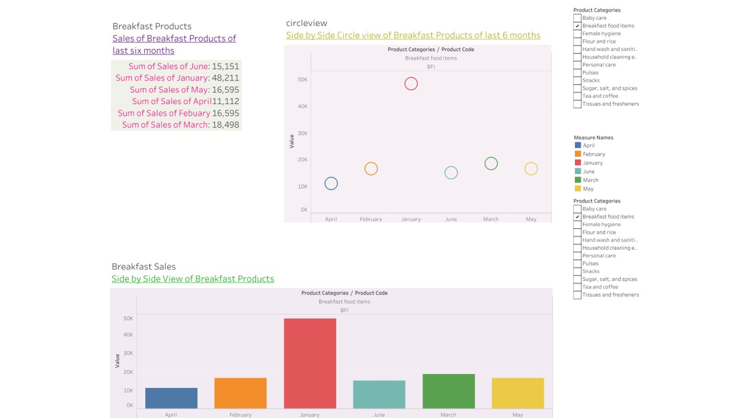

For detailed description of Tableau Project on Amazon Pantry,click on the below mentioned link:

<https://public.tableau.com/app/profile/shivani.priya8178/viz/AmazonPantry_16819876934540/ChicagoDashboardofBreakfastProducts?publish=yes>

<https://public.tableau.com/app/profile/shivani.priya8178/viz/AmazonPantry_16819876934540/ChicagoDashboardofBreakfastProducts?publish=yes>